MORTSCAPE

Domain Competency Training

L1.2: Mortgage Production

Version No. 1.1



 | Prepared By | Reviewed by | Approved By
Name | Manish Kumar | Sanjay Kumar Nishank | Sudhakar Kolangarth
Role
Signature
Date | 18-Oct-05

Project ID: 04763 KT document / Ver: 1.1

Release ID: QTTS-TSTKT.doc / 8.01 / 05.03.2004 C3: Protected

CONTENTS
1.0 Introduction 4
1.1. Scope of Loan Production 4
2.0 Process Flow 4
2.1. Loan origination 4
2.2. Loan Processing 5
2.3. Loan Underwriting 5
2.4. Loan Closing & Funding 5
3.0 Entities Involved 6
4.0 Origination 6
4.1. Client prospecting 6
4.2. Pre-qualification 8
4.3. Rate Locking 9
4.4. Initial disclosures 9
5.0 Processing 10
5.1. Verification of borrower information 11
5.2. Property related information 15
5.3. Credit Scoring 17
5.4. Title Search 18
5.5. Regulatory tasks 18
5.6. Pipeline Risk Management 18
6.0 Underwriting 19
6.1. Evaluation of 3Cs 20
6.2. Validation of Borrower Information details 22
6.3. Loan Re-pricing 22
7.0 Closing and Funding 22
7.1. Loan Closing 23
7.2. Loan Funding – Warehouse Lending 25
7.3. Post Funding Quality Control 28
7.4. Other Concepts – Predatory Lending 28
8.0 Appendix A – Sample Documents 31
8.1. Contract Of Sale Of Residential Property 31
8.2. Mortgage Deed 31

Introduction
Closing Agents
Loan Production is the process of creating a fully funded loan. It covers the loan lifecycle from its primitive stages of client prospecting will the time the loan is closed and funded. The loan life cycle continues even after that when the loan enters the servicing and secondary marketing stage.

Scope of Loan Production
Life of Loan
Loan Production
Loan Servicing
Secondary Marketing

Exhibit 1.1

Process Flow
The various stages involved in a loan production is as shown in exhibit 2.0
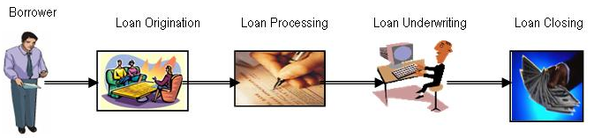

Exhibit 2.0
As can be seen we can identify four distinct phases of the Loan production process.

Loan origination
When a prospective borrower gets engaged with a lender, the lender (or the lender’s agent) asks for the basic data related his loan. This data is used to generate some scenarios (with combinations of interest rates, loan amount, points etc) for the borrower and the borrower is required to “lock” a certain rate scenario, out of the given scenarios, after which his loan can go for processing.

Loan Processing
After a loan is rate locked, it goes through a series of activities where the different documentary requirements are fulfilled and regulatory checks are done. All these activities are part of the Loan processing stage. The borrower may be asked for a lot of information and supporting documentary proof(s) about his employment credentials, financial position, property details and other assets and liabilities associated with the borrower. Various other reports, like credit report, property appraisal etc. are also required for fill processing, which are fired at this stage.

Loan Underwriting

A lot of data is collected through the documents acquired in the processing stage. The data sets in these documents and reports need to be analyzed and churned together to generate meaningful information about the eligibility, overall credit worthiness and risks associated with the loan applied for by the borrower. All this is then factored in to come out with the exact loan pricing to be offered to the borrower.

Loan Closing & Funding

After the loan is underwritten and the borrower agrees with the loan terms, the loan moves into the Closing and Funding stage(s) when the actual contracts are signed and sent, the property is registered and the seller payments are cleared.
The various activities involved in all these stages have been explained in detail later.

Entities Involved
The various entities involved in mortgage production are explained in the exhibit 3.0.

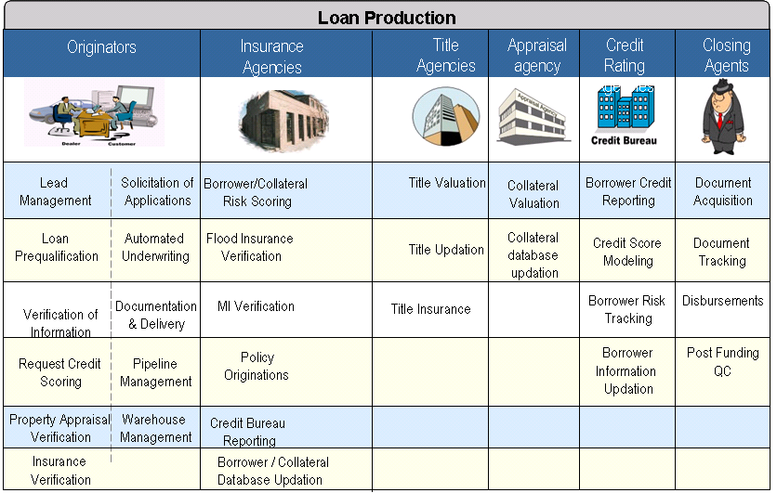

Origination
Loan origination consists of the following activities

Client prospecting

Pre-qualification

Initial Disclosures

Rate Locking

Client prospecting
The primary activity in client prospecting is generating leads for new loan originations. There are various channels of mortgage lead generation and / or origination. Broadly the channels can be classified into two types – retail and wholesale.

Borrower

Lender

Broker
Retail Channel
Wholesale
Channel
Wholesale Channel

Retail Channel
When a borrower comes in direct contact with the lender, the origination channel is said to be retail. Some of the various forms of retail channel are

Bank branches

Existing customers of banks / lender

Call centers

Loan consultants

Lender websites

Wholesale Channel
A vast chunk of loan originations happens through indirect channels where the lender is not contacted directly by the borrowers. There are intermediaries involved who do most of origination activities and may also be able to do some part of processing as well.
There are basically two types of intermediaries in wholesale originations – Brokers and Correspondents.
- Brokers
Brokers are independent bodies who act on behalf of the lender. Unlike a loan consultant who represents only one lender, a broker typically is an agent for multiple lenders. He tries to pre-qualify the borrower credentials with multiple lenders, to get the best possible pricing scenario for the borrower. They may also adjust the pricing by charging points which can be paid to them and not the lender. The flexibility that these borrowers have to offer makes them so popular mode of loan originations. The brokers may or may not be able to also do some part of processing of the loan for the lender. The loans originated by them are closed in the name of the lender.
- Correspondents
Correspondents are banks or financial institutions that have the capability to originate and fund the loan on their own. So, correspondents can act as brokers (when not funding themselves) or mortgage lenders (when they do fund and close the loan in their name). Mortgage lenders forge tie-ups with local financial bodies (thrifts, credit unions, local banks and other financial institutions) so that they can increase their reach and also save on origination costs (by not having to maintain dedicated sales infrastructure).
Loans originated by Realtors, Builders and other real estate and mortgage professionals also are categorized as wholesale channel.

Pre-qualification
In the pre-qualification stage the borrower is required to provide the basic minimum details about his financial strength and the type and value of loan he’s interested in. These details are underwritten against the lender standards and calculations are made to evaluate the lender’s eligibility for the loan. In case he’s eligible, the best possible loan scenario’s are presented to him for him to choose. This whole process is called pre-qualification. Pre-qualification helps to ensure that the borrower is serious for the loan and also makes sure on abroad level that the borrower has the capacity to pay back the loan (installments). If all goes well with the pre-qualification process, you'll receive a "pre-qualification approval letter" telling home sellers that you qualify for a certain mortgage amount. Because it demonstrates to the seller that you are a serious buyer, you can use the pre-approval letter as leverage when you negotiate to buy a house.
The scenarios contain values on the parameters
1 | Type of Mortgage
2 | Loan Purpose
3 | Purchase Price:
4 | Loan Amount
5 | Interest Rate
6 | Discount Points (Credit)
7 | Origination Fee
8 | Annual Percentage Rate
9 | Loan Term (in months)
10 | Initial Principal and Interest Payment
11 | Minimum Down Payment
12 | Maximum Secondary Financing
13 | Private Mortgage Insurance required. (Y/N)?
14 | Private Mortgage Insurance required. (Y/N)?
15 | Escrow/impound account required. (Y/N)?
16 | Escrow/impound account required. (Y/N)?
17 | A prepayment penalty clause required. (Y/N)?
18 | Prepayment Fee Term

Rate Locking
A borrower is given some loan scenario’s after initial pricing based on his credentials. He can choose one out of them. His loan can be processed for his chosen scenario. A typical loan may take from 30 to 60 days to be funded. The lender carries a risk of the interest rates fluctuation in this period. This may be induce the initial pricing conditions to change as per market changes, if the lender wishes to pass on the impact of changes to the borrower. So, the borrower may end up with a different loan agreement altogether. To avoid such uncertainties, the borrower is required to “lock” the rate at which he wants his loan to be processed, by choosing the best possible scenario. This process is called ratelocking. The borrower may have to pay some amount for ratelock, which later is also adjusted with his closing fees, when the loan is closed.
Within three business days of ratelocking, the lender is required by law to send electronically or via the mail a good-faith estimate of the closing costs you will pay. Lenders also are required to give you the government publication A Home Buyer's Guide to Settlement Costs, a detailed discussion of the home-buying process and closing costs, and the Truth-in-Lending Disclosure, a document that discloses important terms of your loan.

Initial disclosures
Before proceeding with loan processing, the lenders are required to appraise the borrower about the complete details of the loan and also about all the charges associated with the loan production (including all the third party charges). These charges may not be exactly true but should be based on the honest judgment of the lender. This step is called initial disclosures and is a legally binding activity for the lender. Disclosures are provided to comply with the following regulations -

- Good Faith Estimate of Settlement Costs (GFE) - The lender or mortgage broker must provide a Good Faith Estimate of settlement service charges that is likely to be paid by the borrower.

- Servicing Disclosure Statement -The lender or mortgage broker must inform the borrower in writing, when loan is applied or within the next three business days, whether it expects that someone else will be servicing the loan.

- Truth in Lending (TIL) Statement – This statement has to be provided as required by Federal Law. It discloses the terms of the loan, including the interest rate, the loan amount, the annual percentage rate (APR) and the total payments required. All these terms are based on initial pricing of the loan. This statement is provided in accordance with the Truth in Lending Act (TILA). TILA ensures that:
  - Credit terms are disclosed in a meaningful way so that consumers can compare credit terms more knowledgeably
  - There are tolerance limits for errors in calculating annual percentage rates or charges as well as guidelines for making disclosures on various transactions
  - Consumers are protected against inaccurate and unfair credit billing practices.

Processing
After ratelock, the loan goes for complete processing. During processing various kinds of statements are required and many other reports are fired. There are specialized agencies which specialize in one particular activity. Collectively all these may be called Settlement providers. Loan Processing consists of
- Verification of borrower information
- Property related information collection and validation
- Credit Scoring
- Title Search
- Regulatory tasks


Property Appraisal, Flood Appraisal & Geocoding

Verification of Employment, Income & Financials
Credit Scoring & Title search
Regulatory tasks - CIP and OFAC Check

Verification of borrower information
The borrower is required to support his financial credentials (as disclosed by him earlier), with supporting documents (in hard and / or soft copy format). He needs to provide statements, in standard acceptable formats and, that validate the following.

Income
Lenders generally say that housing expenses should not exceed 25 percent to 28 percent of the homeowner's gross monthly income called (Debt to Income or DTI ratio). The housing expenses include monthly mortgage principal, interest payments, property taxes and homeowner’s insurance. For example, Federal Housing Administration (FHA) loans, this figure is not to exceed 29 percent of the homebuyer's gross monthly income.
Apart from steady employment, income also includes:
- Overtime bonus and commissions (average for one - two years)
- Net income from self employment
- Social security, veteran's benefits and retirement
- Alimony, child support and income from public assistance programs
- Workman's compensation or permanent disability payments
- Interest and dividend income; rental income after deducting expenses and debt payments
- Income from trusts, partnerships, professional corporations
Debt
Lenders also take into consideration borrower’s regular monthly debts and obligations: other real estate loans, installment loans (bank loans, auto loans, tuition loans, etc), revolving accounts, alimony and child support. Housing expenses plus long-term debts should not be more than 33 percent to 36 percent of gross monthly income. For Federal Housing Administration (FHA) loans, this figure should not to exceed 41 percent of the homebuyer's gross monthly income. Lenders usually define long-term debt as monthly expenses extending more than 10 months into the future. Having the idea of what monthly mortgage payments the borrower can afford will help in determining the maximum loan amount that can be borrowed. The monthly mortgage payment that is affordable will help in deciding the right kind of mortgage. For example, a 15-year fixed-rate mortgage requires higher monthly payments than a 30-year loan.

Down payment
Lenders expect borrowers to have enough money available to make the down payment - usually up to 20 percent of the asking price for the house and to pay closing costs (3 percent to 6 percent of the loan amount). The following sources may be considered for a down payment: savings, stocks and bonds, mutual funds, employee savings plans, Individual Retirement Accounts, etc. Some mortgage programs allow the use of a gift of money from parents or relatives that need not be repaid or grants from a non-profit housing assistance organization for a part of down payment.
If a borrower does not have enough money for down payment that most lenders require, then they may obtain a High-LTV (LTV > 80%) loan and for accessing this loan, the borrowers might be required to take out Private Mortgage Insurance. It allows a mortgage loan with a down payment as low as 5 percent. An FHA, VA or RHS program may also be considered. Down payments on FHA loans can be as low as 3 percent, and closing costs can be wrapped into the mortgage, but FHA loans cannot exceed the statutory limit. RHS and VA loans usually require no down payment but they are only available for eligible applicants.
In recent years, Fannie Mae and Freddie Mac have also introduced low down payment programs:
- Community Home Buyer's Program, Fannie 97® (a 3 percent down payment loan), FannieNeighbors®. If household income is no more than area’s median income, the borrower is eligible for these loan types.
- HomeSteps Special Financing. Only a 5% down payment and no mortgage insurance required.
Local government may support other home buying programs in a specific area. The Pledged Asset Mortgage allows a prospective home buyer who has sufficient income to meet monthly payments toward a home, but who cannot save the necessary down payment, to borrow up to 100 percent of the sales price when a family member pledges a stable financial asset equal to 30 percent of the loan amount.

    - Employment & Financials
Borrower needs to provide a Verification of Employment (VoE) to validate his employment details. It may also be verified by verbal confirmation (verbal VoE). Verbal VoE is accepted in case of low LTV and high credit rating of borrower. The borrower needs to submit documents supporting his financial status in accordance with the level of disclosure he wants to make. The loan price and the loan types usually get determined based on the proofs of documentation provided by the borrower related to his assets, income and employment. Disclosure levels are chosen out of the following options (not exhaustive).
Documentation Type | Employment & Income | Assets
Full / Alternative | Fully verified | Fully verified
Fast Forward | Employment, income, and assets must be fully disclosed on the application. Based on the overall credit quality of the loan, certain income and/or asset documentation waivers may be provided and a verbal VOE and IRS 4506 will be required.
Limited Doc | - Salaried: Verbal VOE and most recent pay stub & W-2 or IRS 4506  - Non Salaried: 1 year personal tax returns & IRS 4506 | Fully verified
Stated Income | Income stated, not verified; Verbal Verification Of Employment (VOE) required | Fully verified
No Ratio | Income neither stated nor verified; Verbal VOE required | Fully verified
No Income / No-Asset (NINA) | Income neither stated nor verified; Verbal VOE required | Neither stated nor verified
No Doc | Neither stated nor verified | Neither stated nor verified

- Full Doc Loans
With this kind of loan all income and assets are documented. Income is documented using pay stubs and W-2s for salaried borrowers. Self-employed borrowers use federal tax returns to verify income. The Loan Application Checklist covers most supporting documents the borrower and any co-borrower will need to supply. Once the borrower has applied, the lender provides him with a detailed list of documentation required to approve the loan. It requires the borrower to provide complete employment, income, and asset information and supporting documentation for each. The information provided by the borrower must cover a defined period (usually 2 years) and must be verified by the lender.
- Fast Forward
Documentation relief for high credit borrowers. The income and assets stated by the borrower must be reasonable for the borrower’s type of employment and line of work. Employment must be verified for a defined period of time.
- Limited Doc
Like full/alternate documentation, limited doc requires that the borrower indicates complete employment, income, and asset information. However, the employment and income information stated by the borrower must be verified for only a one-year period of time.
- Stated Income
Income is stated, but not verified. Employment is verbally verified with no reference to income. Assets are fully verified. The income stated by the borrower must be deemed reasonable by the underwriter (reviewer) for the borrower’s type of employment and line of work. Additionally, the borrower’s stated income must be supported by the amount of verified assets shown on the application.
- No Ratio
Similar to stated income in that it is offered to borrowers with a strong asset base and steady employment. Employment must be verified. Assets are verified based on established criteria. The borrower must meet the definition of perfect credit. The borrower’s income must not be stated, and no income verification may be submitted.
- No Income/No Assets (NINA)
Neither income nor assets are stated or verified. Employment is stated. A verbal verification of employment (VOE) is required.
- No Doc Loans
With No Doc loans, no documentation is provided to substantiate the borrower's income and assets. These loans are mostly for self-employed borrowers who have difficulty verifying all of their income, and for service industry employees, such as bartenders, waiters, and hair stylists who have pay which is difficult to determine precisely. These loans may be also used by borrowers who get most of their income from commissions, or by borrowers with very complex income structures. For example, a borrower who has income primarily from rental properties and investments may be hesitant to verify all sources of income due to the volumes of paperwork this would require.

    - Other Information
The borrower information which needs to be collected includes:
  - Full name, social security number, home phone, date of birth, and years of school
  - Marital status (married, unmarried, separated)
  - Present address
    - Additionally, the borrower must indicate whether the property is owned or rented and how long he/she has lived there

Property related information
The lender orders various kinds of reports to get an independent assessment done for the property. The services of various settlement providers is used to generate the following reports

    - Property Appraisal
An appraisal is an estimate of the value of a property, made by a qualified professional, called an appraiser. An appraisal of the property is a critical factor in determining how much of a mortgage the lender will approve, as the property serves as collateral for the loan.
The appraiser generally is chosen by the mortgage lender, or the borrower can locate a qualified appraiser by contacting one of the professional organizations, such as the Appraisal Institute or the American Society of Appraisers (provided the appraiser is in the approved list of the lender).
The borrower might be refused a mortgage, or offered a smaller amount on the mortgage, if the appraisal falls short of the amount he wishes to borrow. Alternatively, the borrower has to make up the difference with a larger down payment, or renegotiate the sale price with the seller.
The appraiser usually looks at the property from two separate angles to determine its value:
- What would it cost to rebuild the home
- How it compares to other properties of similar size, quality and location that have sold recently

    - Flood Appraisal
In 1968, Congress created the National Flood Insurance Program (NFIP) in response to the rising cost of taxpayer funded disaster relief for flood victims and the increasing amount of damage caused by floods. The Mitigation Division a component of the Federal Emergency Management Agency (FEMA) manages the NFIP, and oversees the floodplain management and mapping components of the Program.

To get secured financing to buy, build, or improve structures in Special Flood Hazard Areas (SFHA's) you will be required to purchase flood insurance. Lending institutions that are federally regulated or federally insured must determine if the structure is located in a SFHA and must provide written notice requiring flood insurance.

Flood insurance is available to any property owner located in a community participating in the NFIP. All areas are susceptible to flooding, although to varying degrees, in fact, 25% of all flood claims occur in the low-to-moderate risk areas. Flooding can be caused by heavy rains, melting snow, by inadequate drainage systems, failed protective devices such as levees and dams, as well as by tropical storms and hurricanes.
A sample flood certificate form is attached here →

    - Geocoding
This involves standardizing the address for the property as per USPS standard

Credit Scoring
Credit scoring is an important part of loan processing. Lenders generally outsource this function to agencies that are specialized in this activity. These agencies have record of all major transactions done (or failed to be done, in case of payments dues etc.) by the borrower in recent history. The lenders generally seek credit reports from more than one vendors and typically calculate an average credit score that’ll be used for underwriting purposes. Credit rating is the key data that decides what type of loan (A, B, C. Alt-A, Sub-prime etc.) the borrower is eligible to take.
Credit scoring systems provided by the reporting agencies like Equifax analyze and combine five key factors to obtain a single credit score. The most important factor, of course, is a borrower's record of paying their debts. Primary emphasis is placed on the last two years of payment history on currently outstanding debts. Thus, one 30 day late payment on a credit card or car loan within the six months prior to a credit scoring date could reduce a total score much more than four late payments four years earlier.
Combined with payment histories, collection accounts and public records are also factored into a borrower's credit score. Medical bills that go to collection, bankruptcies and lawsuit judgments all drag down total scores. Mortgage professionals report numerous instances of borrowers with past bankruptcies on their credit report earning better credit scores than borrowers without one.
Credit scoring systems also look at the number of inquiries to a borrower's credit report over the last six to twelve months. A large number of inquiries can indicate that a borrower has been making an effort to obtain too much new credit too quickly.
Another credit scoring factor is a borrower's outstanding balances against available credit limits. A borrower with $9,995 borrowed on credit cards with $10,000 in credit limits will be severely penalized by all credit scoring systems even with a perfect payment history.
The last consideration of most credit scoring systems is how long open accounts have been open. The longer that a revolving account has been open, the better.
There are over 1000 local and regional credit bureaus throughout the United States. Most credit bureaus are either owned or under contract with one of the nation's three major credit reporting agencies:
- Equifax
- TransUnion
- Experian
These national agencies maintain centralized databases containing the credit records of more than 170-million American citizens.
It is estimated that 50% of all credit reports contain errors significant enough for an individual to be denied a loan. There are basically two types of credit reports available to consumers, "individual" or "merged" reports. Individual reports are provided by the above three major credit reporting agencies, whereas Merged reports offer information from all three of the credit reporting agencies on one easy-to-understand format.

Title Search
The borrower needs to make sure that the property they are going to buy is not under litigation and the seller holds a clear title to the same which can be transferred in his name. If the property title is not clear, then this is a big risk to the lender. Thus lenders order title search reports to make sure that the title to the property is without litigation and is also free from any other lien against it.

Regulatory tasks
There are a few tasks which are required to be done by the lender before funding of the loan. These are legally binding activities to be done by the lender.

Customer Identification Program (CIP)
The US PATRIOT act mandates the financial institutions (lenders) to have an effective Customer Identification Program in place to
1. Collect identifying information about customers opening an account
2. Verify that the customers are who they say they are
Thus all lenders ask for multiple forms of identification proofs pertinant to the borrower.

OFAC Check
The US government maintains a list of individuals who are blacklisted. The financial institutions (lenders) are restricted form entering into any transaction with them. Thus it is mandatory that the lenders verify that the borrower does not belong to that group.

Pipeline Risk Management
Lenders have various kinds of loans at various stages in the production process. These loans are with varying maturities, ratelock periods, borrower credentials and other characteristics. This is called a loan pipeline. A loan becomes a part of the pipeline as soon as it is ratelocked and is supposed to be ‘In Pipeline’ till it is closed and funded. A lender has to mitigate (hedge) the risk of the interest rate changing since the loan was ratelocked (as it cannot pas on the market rate at closing to the borrower – the ratelock is a contract with the borrower to offer the ‘rate’ that is ‘locked’). Lenders have to keep a close watch on their pipeline and hedge against the possible interest rate fluctuations for the loans that they believe will be closed (based on past trends).

Underwriting
Loan Underwriting consists of:
- Evaluation of 3C’s
- Collateral
- Capacity
- Credit
- Validation & Review of Employment status, Income & Appraisal status
- Loan Re-pricing

Today an automated underwriting system (AUS) is becoming more and more popular than the usual manual underwriting. It enables lenders to obtain a risk classification without traditional manual underwriting. Automated underwriting shrinks the mortgage approval process from weeks to minutes, saving borrowers time and money and eliminates much of the frustration and uncertainty involved in getting a mortgage. The objectivity of the system also assures consumers that their applications will be evaluated fairly. The automated underwriting systems also support risk based pricing of loans. Risk-based pricing utilizes an individual borrower’s specific information to produce pricing for a loan, wheras in traditional pricing the average performance of loans with similar characteristics are used to produce pricing for a loan.
Desktop Underwriter (DU) and Loan Prospector (LP) are two such AUSs, which are being made available by Fannie Mae and Freddie Mac.

After careful analysis of the collateral and borrower information, the lender determines whether the loan request will be approved. If you're turned down for the loan, you'll probably have to pay the lender's processing costs, which may include (but are not limited to) application, appraisal, and credit-report fees. The lender is required to explain — in writing, within 30 days of its decision — the reasons for denying credit.
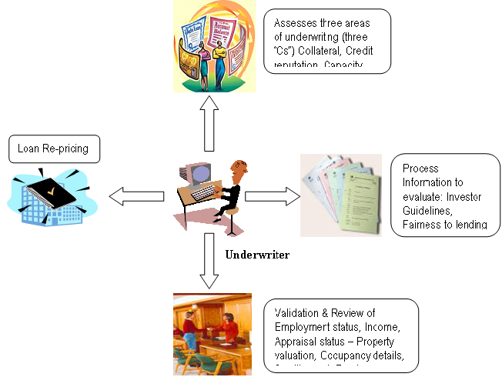

Exhibit 6.0

Evaluation of 3Cs
In the Loan Underwriting process, the lender evaluates the loan application and borrower based on collateral, credit pull and capacity of borrower to pay back the mortgage.
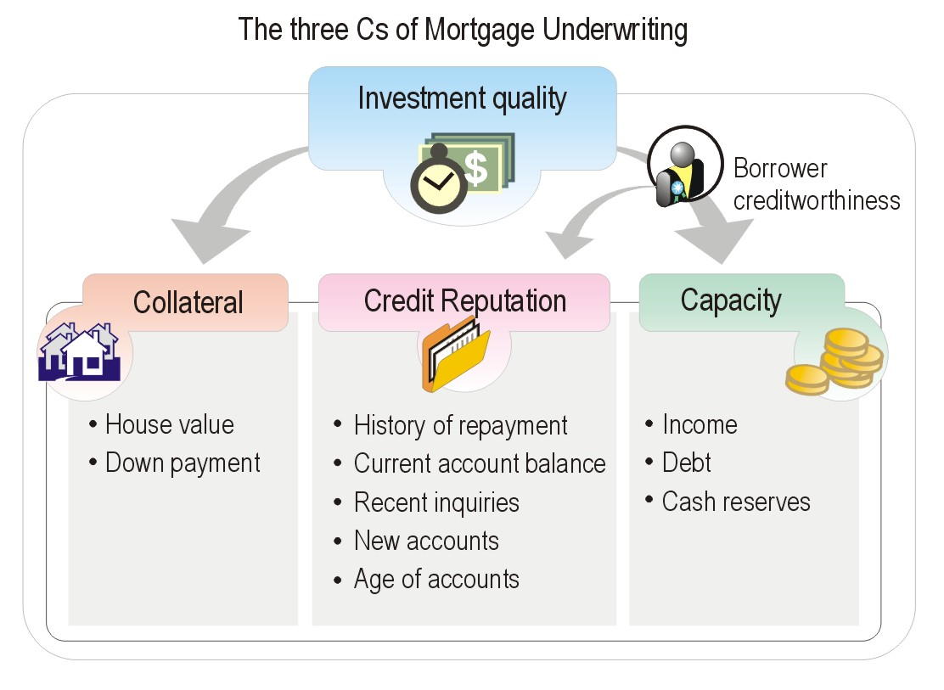

Exhibit 6.1

Collateral
When reviewing collateral, lenders look at house value, down payment and property type.
- Appraised value of the house
The lender wants to make sure that the value of the home would support the amount of mortgage. Usually, the amount of the loan cannot be more than 95 percent of the appraised property value or 95 percent of the sales price of home, whichever is lesser.
The lender will arrange to have a third party agency estimate the market value of the house (if it has already not been done). The appraiser looks at what the home is worth today and how the neighborhood may affect future property value.
- Down payment. Lenders usually expect the borrower to make a down payment of between 10 and 20 percent of the house's price and to pay closing costs, often three to six percent of the loan amount. There are many special programs for first-time home buyers and low to moderate-income home buyers that allow a smaller down payment - as low as 3 percent, or even no down payment, in some cases. With the smaller down payment loans, however, borrowers are required to carry Private Mortgage Insurance. Lenders may also verify the origin of down payment.
- Property Type

Capacity
When looking at capacity income, debt, and cash reserves of the borrower are verified. All necessary documents will significantly speed up the application process. All of these things can help the lender understand how well a borrower can repay a mortgage loan. Lenders generally prefer that housing expenses (including mortgage payments, insurance, taxes, and special assessments) not exceed 25 to 28 percent of gross monthly income. Other long-term debt (monthly payments extending more than 10 months) added to the housing expenses should not exceed 33 to 36 percent of gross monthly income.

Credit reputation
Credit history is considered when lenders review the credit reputation of the borrower. The Credit Report (which was ordered during the loan processing stage), is utilized to check the borrower’s ability to repay a loan. If there are any credit related problems such as history of late payments, foreclosures or judgments, the lender may clarify by asking for a written explanation or clarification of any problems.

Validation of Borrower Information details
During the underwriting stage, the loan underwriter does a second level review and validation of all the documents to verify information supplied by a mortgage applicant, such as income, employment, and down payment sources. Also the appraisal report of the financed property is verified to determine if its value is sufficient to serve as collateral for the mortgage.

Loan Re-pricing
The re pricing of the loan (another iteration of the loan pricing) is done in the underwriting stage. The process which is followed in this phase is essentially similar to the steps which are described in the loan pricing stage of the loan origination phase. The loan parameters will be checked against the guidelines provided by the private investors or the GSEs to arrive at various loan pricing scenarios. In case the loan scenarios generated in this phase are significantly different to what were originally mentioned to the borrower, these conditions need to be discussed with the borrower and if required additional documents or conditions need to be met by the borrower for the approval of the loan.

If after the initial guidelines check is done and a loan confirms to the Fannie Mae and/or Freddie Mac guidelines, then the loan parameters need to be sent to the DU and/or LP for underwriting so that the loan can be ultimately sold to the agencies.

Closing and Funding
This is the last leg of the Mortgage Production cycle and consists of the following activities
- Loan Closing
- Loan Funding
- Post Funding Quality Control
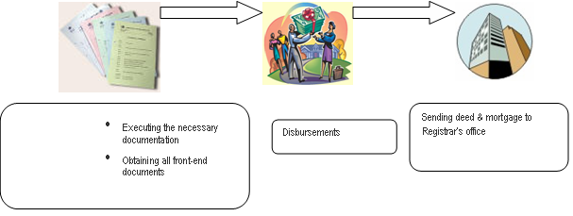

Exhibit 7.0

Loan Closing
The closing agent will have received instructions from the lender on how the loan is to be documented and the funds disbursed, and will have collected all of the necessary exhibits from the borrower, the seller and the lender. The closing agent will make sure that all necessary papers are signed and recorded and that funds are properly disbursed and accounted for when the closing is completed. Usually, the funds are transferred from the lender to the closing agent’s account who subsequently transfers the amount to the borrower’s/property seller’s bank account (see Sec 7.4 – Warehouse lending also). The borrower typically needs to come to the closing with a certified check for the closing costs, including the balance of the down payment. The borrower can get the exact figure a day or two prior to the closing from lender or the closing agent.

Closing Costs
One business day before closing, borrowers have the right to request a copy of the HUD-1 Settlement Statement, a document that provides an itemized listing of the amounts that the buyer and the seller will pay at closing. Also known as the "closing statement" or "settlement sheet," the HUD-1 will at this point contain only the best information the lender has at the time, so its figures may change by the time you close.
The following list reviews many of the costs that will be itemized on the HUD-1 Settlement Statement:
- Items Payable in Connection with the Loan.
These generally include points and other fees payable to your lender. The appraisal and credit report fees are typically labeled POC — "paid outside closing" — because borrowers typically pay these at the time of application. There is a charge for flood insurance, which provides protection for the lender if you are in a flood-hazard area. Alternately there can be a nominal fee to cover the cost of certifying that you are not in a flood zone.
- Items Required by Lender to Be Paid in Advance
Commonly called "prepaids," these may include a mortgage insurance premium, homeowner's insurance, and mortgage interest from the date of closing to the beginning of the period covered by the first monthly mortgage payment.
- Reserves Deposited with Lender
These are items (such as homeowner's insurance, mortgage insurance, property taxes, and annual assessments) that will be held in an escrow account by the lender for payment as they come due.
- Title Charges
This category includes the cost of the lender's title insurance, which is regulated, varies from state to state, and is based on the value of your home and the amount of your mortgage. Other charges, such as the settlement fee, attorney and notary's fees, and title search fees, may also be itemized here.
- Government Recording and Transfer Charges
This category includes (if applicable) recording fees, city/county stamps, and state tax/stamps payable for both deed and mortgage, and transfer taxes.
- Additional Settlement Charges
These may include pest inspection, house location survey, and messenger fees for delivering documents to be recorded in the land records at the courthouse.
- Property taxes are typically prorated between the buyer and seller
For example, if the seller has paid taxes for a period of time beyond the closing date, you would reimburse the seller. But if the seller has not yet paid taxes for the current period, the amount owed is deducted from your settlement payment. When this occurs, it is called an "adjustment”.

Closing Documents
Among all the documents you'll be required to sign at closing, three are critical:
- Mortgage (Promissory) note.
This specifies the terms of your agreement with the lender and the terms for repayment, including a late charge if you do not pay in a timely fashion.
- Deed of Trust
A document in which a borrower pledges his or her property to the lender as security, or collateral, for the repayment of the amount borrowed to purchase the home.
- Deed
The document by which title to (meaning, ownership of) real property is transferred or conveyed from one party to another, such as from a home seller to a home buyer.
- In case of a newly constructed property –
Borrower will also need a land survey, all receipts for tax payments during construction, a Certificate of Occupancy (required by building code in many areas), and certificates from the local health department for plumbing and sewer installations, required in most areas.
If everyone agrees that the papers are in order, borrower and the seller will each submit a certified check or cashier's check to cover the closing costs and the balance of funds due. The check from the “lender” covering the mortgage amount will then be submitted to the closing agent. If the lender will be paying your property taxes and homeowner's insurance for the borrower, a new escrow account will be established at this point.
Then, the borrower receives the keys to their new home!

Loan Funding – Warehouse Lending
Post Closing the loans are said to be in ‘warehouse’ till they are pooled, sold and delivered to an investor. Pooling requires production of a certain (mutually agreed upon with the investor) no of loans. Also there must be a buyer of the loan (pools) which need to be fetched. The investors (buyers) would also take time to verify that the pool confirms to their requirements and meets their standards (pool size, mean interest rate, borrower credit score ranges etc..). In this meanwhile the lenders’ money is blocked in the loans in warehouse till they are successfully shipped and investors credit them back with the sale proceeds. Lenders need funds to continuously originate loans.

Warehouse lending is an interim financing arrangement for the lenders, to finance new origination while old loans (in warehouse) are in the process of getting sold. Warehouse lenders are lenders to the lenders. The primary lenders have a line of credit approved for them, from the warehouse lender, within which they can raise funds. The following is the detailed process –
- Approved customers submit a pre-funding package
Required documents in pre funding package –
  - Completed loan application (Form 1003)
  - Appraisal - first two pages
  - Firm Commitment by D.E. Underwriter (FHA), VA Loan Analysis by VA Automatic Underwriter (VA), Investor Underwriter, LP or DU approvals from authorized channels (FNMA, FHLMC)
  - Copy of Borrower's credit report
  - Insured closing letter in the name of the originator from the title company
  - Wiring instructions
  - Copy of hazard insurance policy or binder of coverage
  - Flood certification
  - Mortgage insurance or guaranty, certificate of eligibility (if applicable)
  - Purchase commitment from investor - investor lock
- On approval of package received, the funds are sent directly to the settlement (or closing) agent, in escrow, for closing
- On closure of the mortgage loan, the settlement agent sends the original mortgage note to the warehouse lender, endorsed in blank, and a copy of the HUD-1. Following is a more exhaustive list –
  - Original signed mortgage note
  - Certified copy of deed of trust
  - Copy of title commitment
  - Copy of HUD-1
  - Copy of Truth-In-Lending
- The balance of the package remains with customer in most of the cases
- The customer post-closes the mortgage loan and prepares it for delivery to the investor
- The customer ships the credit package to its investor
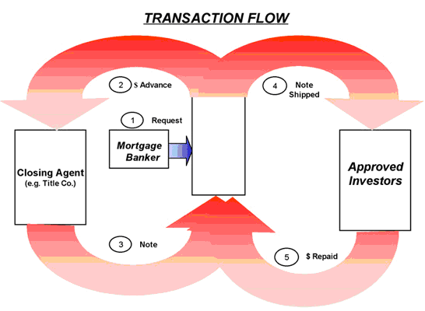
Warehouse Lender

Exhibit 7.2
- On receipt of its delivery instructions, the Warehouse Lender ships the note
- The Warehouse Lender completes the endorsement and ships the note in accordance with the customers instructions, accompanied by the Warehouse Lender’s bailee letter to the investor
- The investor transfers the purchase proceeds to the Warehouse Lender’s collection account
- The Warehouse Lender subtracts the following:
  - Warehouse Facility Principal
  - Interest (payable to warehouse lender)
  - Loan Transaction Fees due
- The balance, which is the customers profit, is transferred to the customer’s bank account
- Treasury and Finance applications in the enterprise, usually provide the customer with details of all receipts, deductions and transfers on a loan-by-loan basis

Post Funding Quality Control
HUD, Freddie Mac, Fannie Mae, Ginnie Mae, and most private investors require the lender to have a quality control unit that independently assesses the quality of loans originated or purchased. The quality control function tests a sample of closed loans to verify that underwriting and closing procedures comply with laid down policies or practices, government regulations, and the requirements of investors and private mortgage insurers. The unit confirms property appraisal data and borrower employment and income information. It also performs fraud prevention, detection, and investigation functions. It also checks for compliance with various regulations.

Other Concepts – Predatory Lending
Predatory lending is an umbrella term that is generally used to describe cases in which a broker or originating lender takes unfair advantage of a borrower, often through deception, fraud, or manipulation, to make a loan that contains terms that are disadvantageous to the borrower. While there is no universally accepted definition, predatory lending is associated with the following loan characteristics and lending practices:
- Excessive fees
Abusive loans may include fees that greatly exceed the amounts justified by the costs of the services provided and the credit and interest rate risks involved. Lenders may add these fees to the loan amounts rather than requiring payment up front, so the borrowers may not know the exact amount of the fees they are paying.
- Excessive interest rates
Mortgage interest rates can legitimately vary based on the characteristics of borrowers (such as creditworthiness) and of the loans themselves. However, in some cases, lenders may charge interest rates that far exceed what would be justified by any riskbased pricing calculation, or lenders may “steer” a borrower with an excellent credit record to a higher-rate loan intended for borrowers with poor credit histories.
- Single-premium credit insurance
Credit insurance is a loan product that repays the lender should the borrower die or become disabled. In the case of single- premium credit insurance, the full premium is paid all at once—by being added to the amount financed in the loan—rather than on a monthly basis. Because adding the full premium to theamount of the loan unnecessarily raises the amount of interest borrowers pay, single-premium credit insurance is generally considered inherently abusive.
- Lending without regard to ability to repay
Loans may be made without regard to a borrower’s ability to repay the loan. In these cases, the loan is approved based on the value of the asset (the home) that is used as collateral. In particularly egregious cases, monthly loan payments have equaled or exceeded the borrower’s total monthly income. Such lending can quickly lead to foreclosure of the property.
- Loan flipping
Mortgage originators may refinance borrowers’ loans repeatedly in a short period of time without any economic gain for the borrower. With each successive refinancing, these originators charge high fees that “strip” borrowers’ equity in their homes.
- Fraud and deception
Predatory lenders may perpetrate outright fraud through actions such as inflating property appraisals and doctoring loan applications and settlement documents. Lenders may also deceive borrowers by using “bait and switch” tactics that mislead borrowers about the terms of their loan. Unscrupulous lenders may fail to disclose items as required by law or in other ways may take advantage of borrowers’ lack of financial sophistication. Prepayment penalties. Penalties for prepaying a loan are not necessarily abusive, but predatory lenders may use them to trap borrowers in high-cost loans.
- Balloon payments
Loans with balloon payments are structured so that monthly payments are lower but one large payment (the balloon payment) is due when the loan matures. Predatory loans may contain a balloon payment that the borrower is unlikely to be able to afford, resulting in foreclosure or refinancing with additional high costs and fees. Sometimes, lenders market a low monthly payment without adequate disclosure of the balloon payment. Predatory lending is difficult to define partly because certain loan attributes may or may not be abusive, depending on the overall context of the loan and the borrower. For example, although prepayment penalties can be abusive in the context of some loans, in the context of other loans they can benefit borrowers by reducing the overall cost of loans by reducing the lender’s prepayment risk.

Originating lenders or brokers that engage in abusive practices can make high profits through the excessive points and fees that they charge, particularly when borrowers make their payments regularly. Even when a loan enters foreclosure, the originator of a predatory loan may still make a profit due to the high up-front fees it has already collected. Moreover, a lender that sells a loan in the secondary market shortly after origination no longer necessarily faces financial risk from foreclosure.2 Similarly, a mortgage broker that collects fees up front is not affected by foreclosure of the loan. Predatory lending also serves to harm the reputation of honest and legitimate lenders, casting them in the same suspicious light as those making unfair loans and thus increasing their reluctance to extend credit to the traditionally underserved communities that are often targeted by abusive lenders.

Appendix A – Sample Documents

Contract Of Sale Of Residential Property

Mortgage Deed

Credit Report


Property Appraisal Checklist


Loan Re-pricing
Assesses three areas of underwriting (three “Cs”) Collateral, Credit reputation, Capacity

